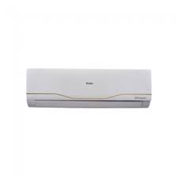

Haier AC

* Cooling Capacity 1.5Ton
* Hot & Cool Ac
* Customer Support Team
* Color White
* Rs.61,847